Tony and I are very thankful for our friends and family and for the good
fortune that has come our way this year. We are SO blessed! Tony has finally fulfilled
his 26 year dream of being able to retire from Delta Air Lines. While I am grateful
that I still have my job with Worldspan, I am sad about my friends who have lost
their jobs. We have also been reminded this year of what a precious gift our health
is as we have been touched by friends and family facing illness and loss.
Let’s hope that the New Year brings good health and good fortune to all!

We have traveled more than ever this year! I started the year with a ski trip
to Salt Lake City, Utah with my sister’s family. We had a great time skiing and snow-
boarding at Brighton and the Canyons. Tony and his brother went to the Detroit Auto
Show while I was in Salt Lake. Then Tony and I finished off January with two
gambling trips – one to Biloxi and one to St. Louis.

In February, we went to Prague, Czech Republic. It is still one of our favorite
destinations. It is beautiful, easy to get around and cheap. The people are
friendly and the architecture and statues are breathtaking.

March started with another quick trip to Biloxi to try our luck at the blackjack
tables followed by a relaxing weekend in St. Simons with friends.

In April, we took our first “Adventure Cruise”, in Oregon, cruising up
the Columbia and Snake rivers on the Wilderness Discoverer,
anchoring several times to go kayaking or hiking.

Early in May I went to Hilton Head with my girlfriends under the guise of
playing golf, but we spent more time relaxing by the pool than golfing (we
didn’t even finish 9 holes). Later in the month Tony and I flew to Germany and took
the train to Rudesheim where we rented bicycles and rode down river to St.
Goar and Koblenz. We took a sight-seeing boat back to Boppard and then
bicycled back to Rudesheim. On a day trip to Boston (where it was cold and windy),
we took a Whale Watching tour. The boat ride was less than pleasant and no one saw
any whales. But we did get a rain-check to save for a sunny calm day!

We took another less than pleasant boat ride in June during a trip to Ireland; the
ferry boat to Inisheer. Once we started feeling better after the rough ride
we enjoyed sightseeing on the island. The boat ride back was calmer! Then we
took a lovely hike from Doolin to the Cliffs of Moher. After that, the walk got
long and our feet got tired so we tried our thumbs at hitch-hiking. This yielded
an enjoyable ride to Ennis with one of the staff from the University of Limerick.

July was mostly filled with retirement celebrations, but we did squeeze in one trip
To Germany for a drive through the Black Forrest. Tony worked his last day at
Delta on his 52nd birthday (July 22). There was a small celebration with cake and
punch followed by our drive to Hilton Head for the Worldspan Golf Tournament.

We saved the big retirement celebration for the next weekend. Tony was overwhelmed when more than a hundred of his friends stopped by the party at our old hang-out near the airport to wish him well in his retirement!

Tony almost went stir crazy during August, his first month of retirement. He was a GREAT house-husband though, making dinner every day, cooking, cleaning and doing the laundry. Sometime around mid-month he decided to start looking for a job. Since he had experience working for the Delta Credit Union, he sent an e-mail to Lockheed Credit Union and before he knew it they had agreed to hire him as a contract programmer.

In September, before he started his new job, Tony flew to Richmond with a friend to help drive her parents’ car back to Atlanta. Then he and I flew to St. Louis and stayed near the Arch, playing a little blackjack on the Queen Casino boat while we were there. I joined my girlfriends at the Delta Ladies’ Golf Tournament in Palm Springs, California. We had a great time even though one of the days we played in what seemed like gale force winds.

In October, to keep our taste buds in shape, we judged BBQ at the Big Pig Jig in Vienna and then attended a friend’s 50th birthday party in Albany (All-benny) Georgia. Then it was back to Prague for Tony and I and several friends. We got to spend some time inside the police station this time while trying to communicate that our friend’s backpack had been stolen. After a few days of sight-seeing in Prague, we flew to Amsterdam and spent a day on the coast at Zandvoort.

Our first trip in November was to Meersburg, Germany with several friends. We flew to Zurich and took a train and a ferry to get there. We spent some time in Konstanz on our way back to Zurich. Back in Georgia, I had the honor of being a “finals” judge at the Richland Pig Fest this year. Tony judged the “Whole Hog” category. It is a tough job, but someone has to do it! We reinstated the Thanksgiving trip with gusto this year by taking two teenagers (niece and nephew) with us. We were a ten group (five adults & five teens) in Rudesheim, Germany where we visited the Christmas Market, hiked through the vineyards and bicycled to some castles.

December has just started and, once again, taken me by surprise. I doubt we’ll find time to do any traveling for the rest of the year. We are looking forward to celebrating the season close to home with friends and family. You are invited to read more about our travels on our website www.bjandtony.com. We would love to hear from you. You can send email to bjandtony@bjandtony.com.

Happy Holidays!

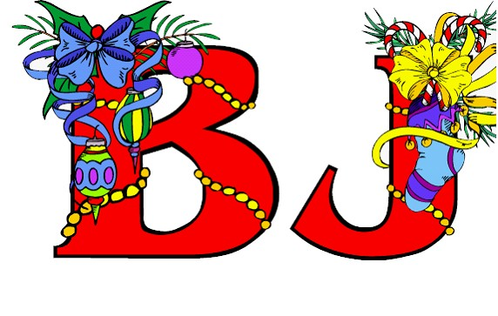
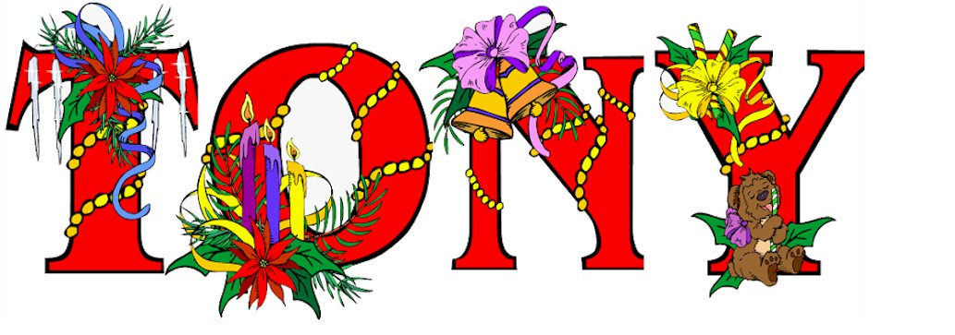
and

